JavaScript - NodeJS

Node.js

Node.js is a program for running JavaScript on the command line rather than in the browser. Therefore, it can be used to create the backend of a webapp, creating ‘fast and scalable network applications’ and allowing for a full webapp backend and frontend to be programmed in just one languauge.

Node is an asynchronous event drive framework, being able to handle many connections concurrently, however it is not mutlithreaded. Node can act as asynchronous since it is non-blocking in execution. Therefore until a larger function is ready to execute it will wait, allowing other smaller functions to be processed in the meantime.

NPM

NPM is a JavaScript package manager, similar to what gem is to Ruby. It can be used to create projects and allow for quick install of all packages required to run a specific project/server.

To start a Node project first initialize npm and fill in the project details using:

npm init

To add packages simply use:

npm install <package-name>

Express.js

Express is a server framework used to create scalable backend JavaScript applications.

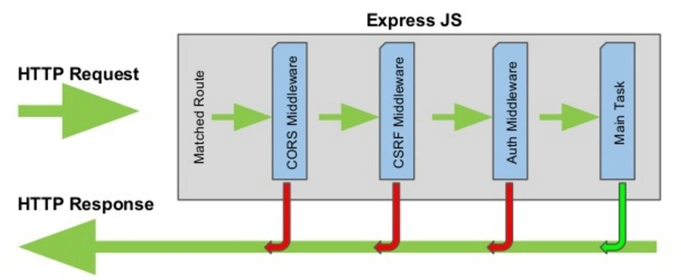

Express can be installed into a project using npm:

npm install express --save